**CODING TASK – 20-06-2025**

**Q1. Understanding Access Specifiers**

**Create a class Student with public, protected, and private attributes, and implement the required methods.**

class Student:

def __init__(self, name, roll_number, marks):

self.name = name # Public

self._roll_number = roll_number # Protected

self.__marks = marks # Private

def display_details(self):

print(f"Name: {self.name}")

print(f"Roll Number: {self._roll_number}")

print(f"Marks: {self.__marks}")

def _update_roll_number(self, new_roll):

self._roll_number = new_roll

print(f"Updated Roll Number: {self._roll_number}")

def __update_marks(self, new_marks):

self.__marks = new_marks

print(f"Updated Marks: {self.__marks}")

def access_private_method(self, new_marks):

self.__update_marks(new_marks)

**Q2. Demonstrate Access**

**Create an object and try accessing/modifying attributes.**

# Create object

student = Student("Lokanya", 101, 95)

# Public: Can access directly

print("\nAccessing Public Attribute:")

student.name = "Lokanya G"

print(student.name)

# Protected: Can access but by convention should be avoided

print("\nAccessing Protected Attribute:")

student._roll_number = 102

print(student._roll_number)

# Private: Direct access will fail

print("\nTrying to Access Private Attribute Directly:")

try:

print(student.__marks)

except AttributeError as e:

print("Error:", e)

**Q3. Inheritance and Access Control**

**Subclass Topper trying to access protected and private members.**

class Topper(Student):

def try_access(self):

print("\nInside Subclass:")

# Can access protected

print("Accessing protected _roll_number:", self._roll_number)

# Cannot access private directly

try:

print("Accessing private __marks:", self.__marks)

except AttributeError as e:

print("Error accessing private attribute:", e)

# Create Topper object

topper = Topper("Anu", 201, 99)

topper.try_access()

**Q4. Use of Name Mangling**

**Access private attribute __marks using name mangling.**

print("\nAccessing Private Attribute Using Name Mangling:")

print(student._Student__marks) # Accessing private variable

**OUTPUT**

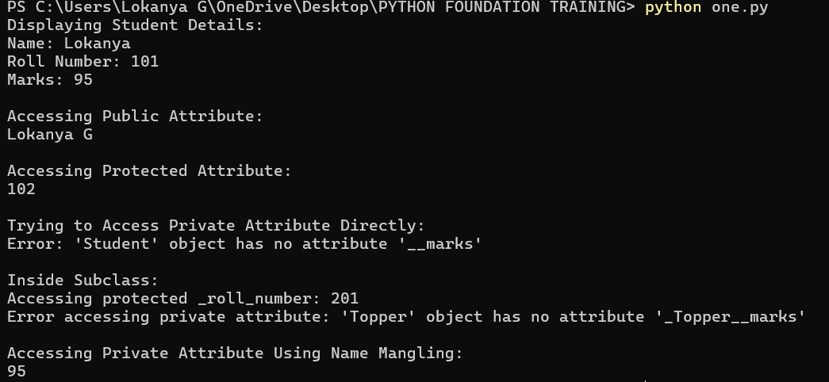

**Q5. Reflection**

1. **Why can’t private members be accessed directly?**  
    Private members in Python use double underscores to prevent accidental access and modifications. They are name-mangled to protect internal state and logic.
2. **What is the purpose of using protected members in class design?**  
    Protected members (single underscore) are meant to signal that the attribute is intended for internal use or subclass use, but not for external use directly.
3. **How does name mangling help with private members in Python?**  
    Name mangling adds a prefix _ClassName to private variables, making it harder (but not impossible) to access them from outside, providing a level of encapsulation.